Sea Level Hotel

In our 4 star Sea Level Hotel , we care about the food and the drink not only of our visitors but also for anyone who wants to combine tradition with new ideas.

We specialize on the Mediterranean and Greek cuisine, with the use of selected products of exceptional quality and the variety of dishes.

Our Amfora restaurant bar is designed in such way so you can enjoy your breakfast or dinner. Full light , unique sea views, cool room , comfortable seating , all together creating the right atmosphere to trigger your appetite.

Sea Level Hotel has a private seaside area as well as a carefully designed outdoor swimming pool where guests can enjoy their bath safely.

The hotel consists of 45 rooms , divided into the following types:

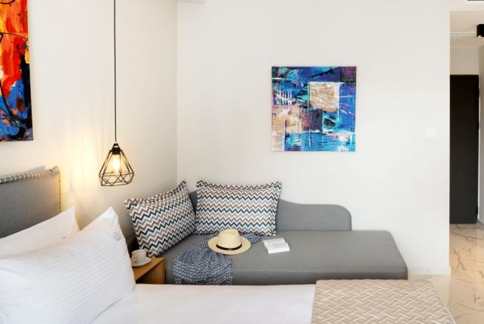
The Premium Side Sea View room ,which has a partial sea view , occupies up to 2 people as it has a king size bed and a bathroom with shower.

The Superior Side Sea View room ,
which occupies up to 3 people as it has a king size bed
and a sofa that can be used
as a single bed in the guests disposal.

- The Executive Side Sea View room, which can accommodate up to 4 people. An open space room with a king size bed and a couchette sofa which can accommodate 2 more people.
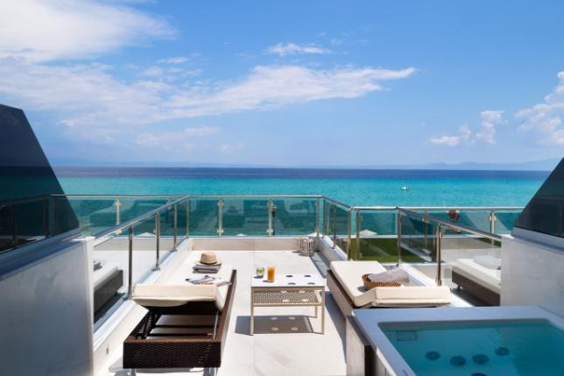

The Junior Sea View Suite with External Jacuzzi,
a cozy suite with brilliant sea view ,
an outdoor Jacuzzi and a folded sofa.

- The Honeymoon Sea View Suite, a special room with sea view, which consists of a separated bedroom with a king size bed and a living room area with a corner sofa.

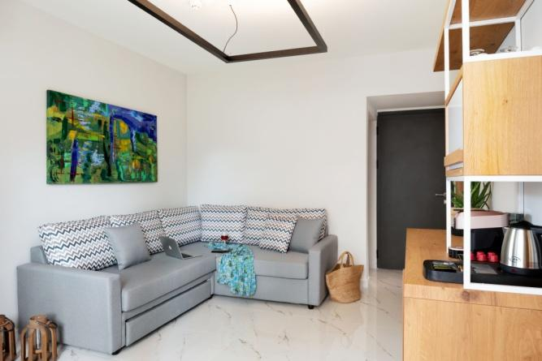

The Family Side Sea View room ,
a very comfortable 3 space room ,
which consists of two bedrooms with king size bed,
the one having its own bathroom and a corner sofa living room in between with a bathroom too.

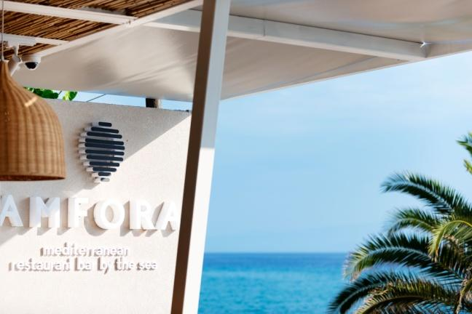
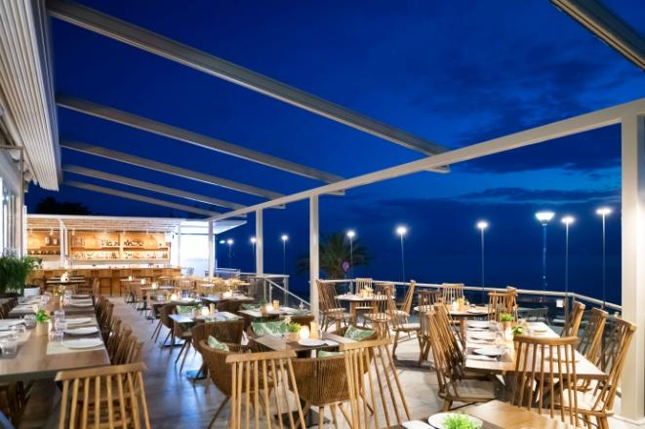

As part of our Hotel ,Amfora Mediterranean Restaurant Bar by the Sea is introduced, a fresh place located in front of the sea.

The best place to enjoy Mediterranean gastronomic proposals combined with an enriched Wine List from Greek and international vineyards.

The multidimensional character of Amfora makes it an ideal choice for couples, families and individual visitors alike.

The hotel’s open air parking is located 50m far from it. It is dedicated to guests and free of charge at their disposal.

